System Breakdown
Top Level Block Diagram
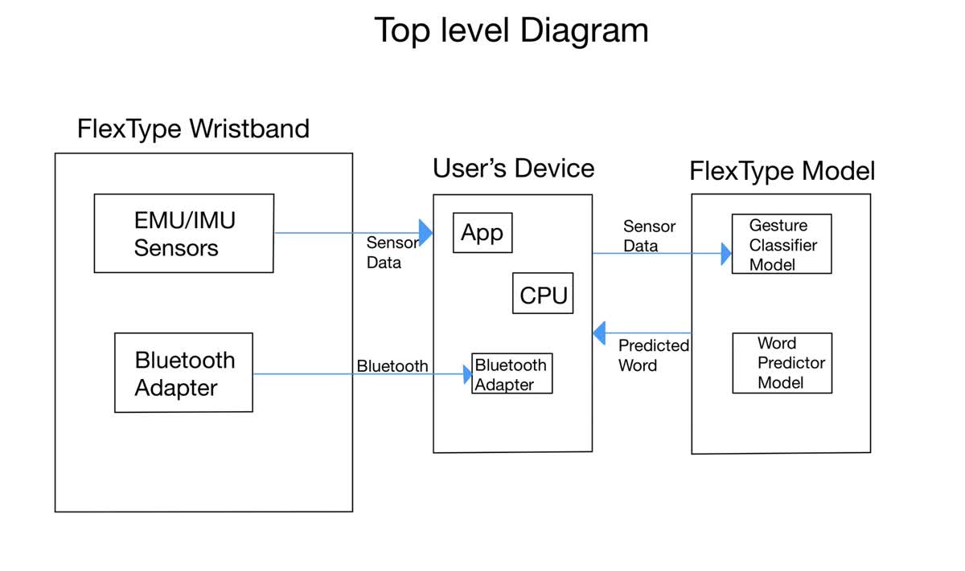

Wristband Sub-System
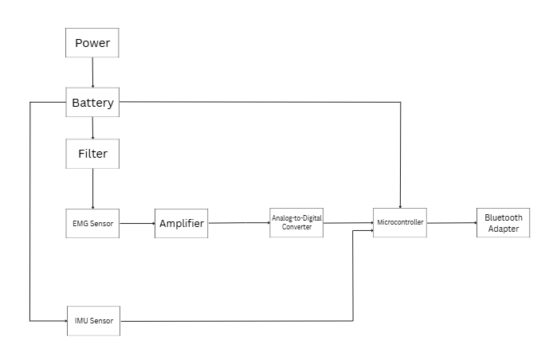

User Device Sub-System
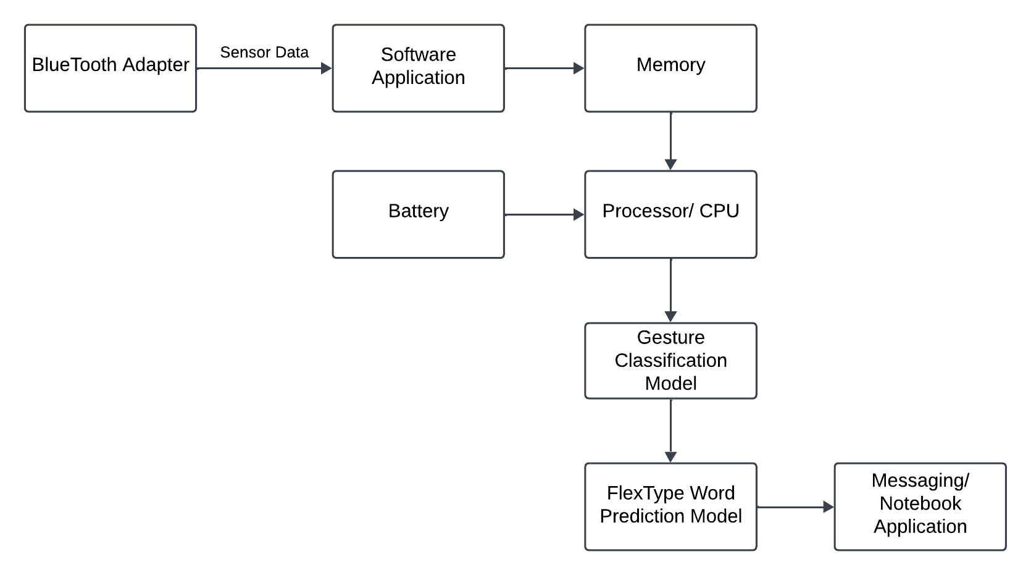

FlexType Model Sub-System
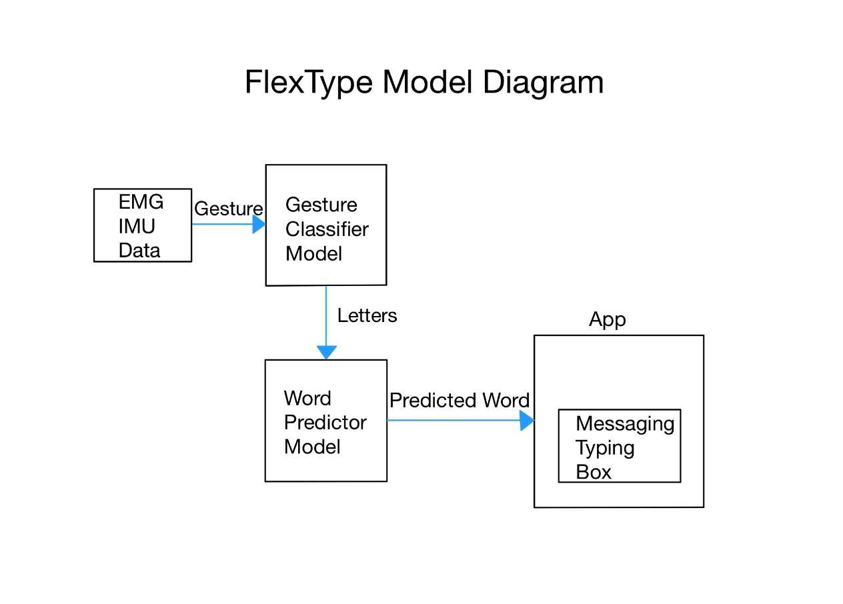

Software System
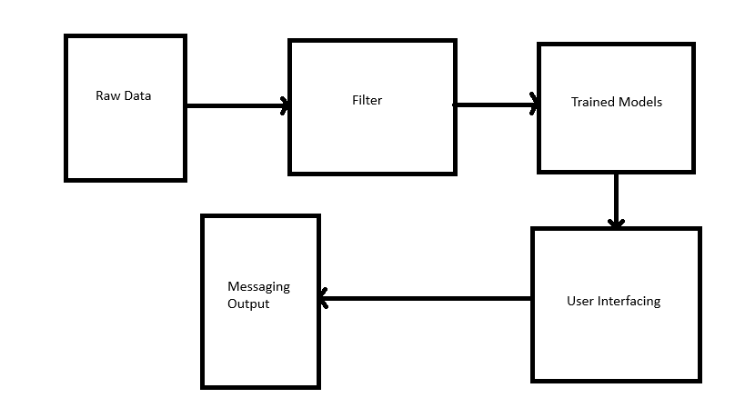

Requirements
Functional
- The wearable device shall operate in a low-power sleep mode when not in active use
- The EMG wristband shall convert the analog EMG signal into a digital signal
- The EMG and IMU sensors shall share signals wirelessly with the user’s device
- The gesture classification and word prediction models will run locally on the user’s device
- The final typed output may be compatible with text-to-speech

Operational
- The wearable device shall only read gestures when a user’s arm is in a certain position
- The EMG sensor shall read a user's gesture within a 1 second period
- The gesture model shall wait for the gesture that indicates a space or period to begin sending the saved data to the word prediction model
- The model shall include a “backspace” gesture for incorrectly typed words
- The model shall include a “swipe” gesture to update incorrectly predicted words

Performance
- The gesture classification algorithm shall have an accuracy of at least 90%
- The word prediction algorithm shall have an accuracy of at least 90%

Manufacturability
- The wearable device shall weigh no more than 50 grams

Reliability and Availability
- The battery life shall last at least 60 hours
- The gesture classification and word prediction models shall be operational on user demand

Environmental
- The system shall operate in the temperature range of 0°C to 50°C

